ASSIGNMENT 5

USING SINGLE CATCH

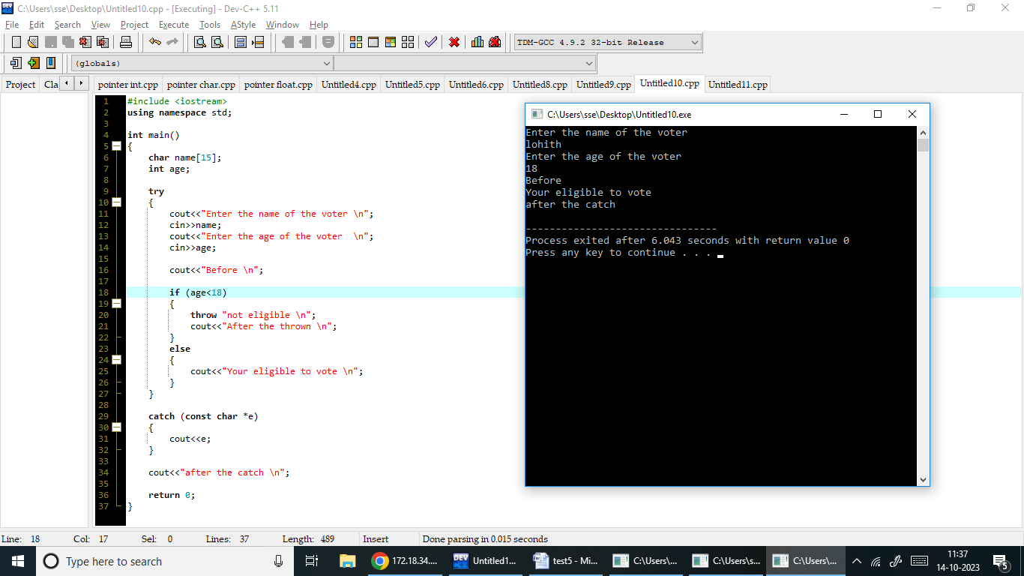

USING MULTIPLE CATCH

